Switch Adapted Attendant Call System

Check Option | Price | Equipment Description
Call System
 | $145.00 | 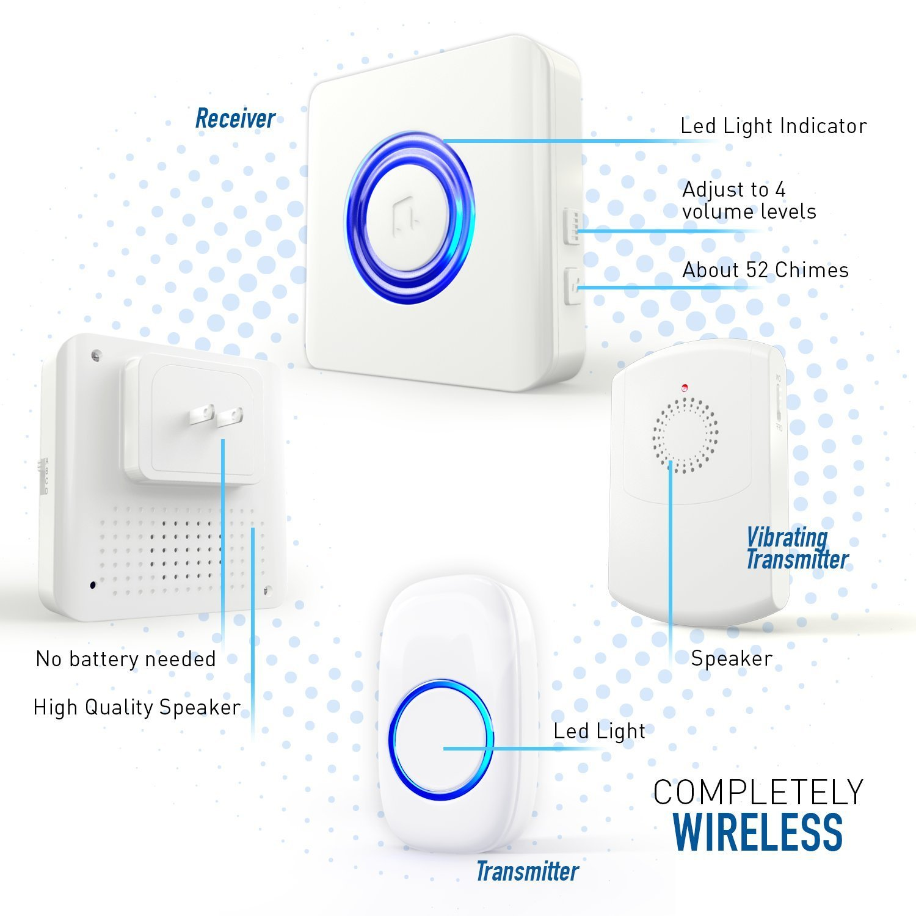  Switch Adapted Attendant Call  This is a call chime to get the attention of a caregiver.  There is a wall unit that flashes light and makes a sound as well as a wireless pager that makes a sound and vibrates.  The user operates the system by pressing an  ability switch – see choices below.
Ability Switch – Choose One
Pillow Switch | $125.00 | Pillow Switch  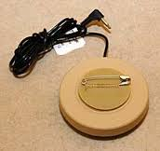  3.5” Diameter | Candy Corn Small  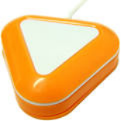  2” Diameter | Candy Corn Large  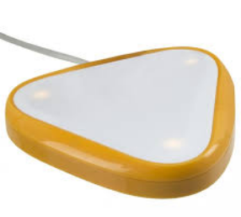  3.5” Diameter | Light Touch Switch  Approx 1.5” long, .5” wide | Button Switch  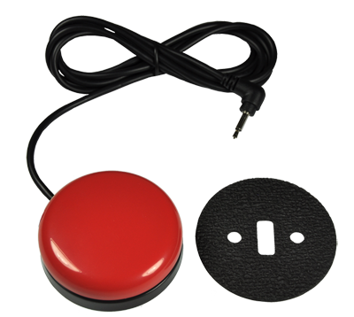  Approx 2.5” diameter
Candy Corn Sm | $195.00
Candy Corn Lg | $215.00
Light Touch Switch | $35.00
Button Switch | $50.00
Add Mount
 | $270.00 | 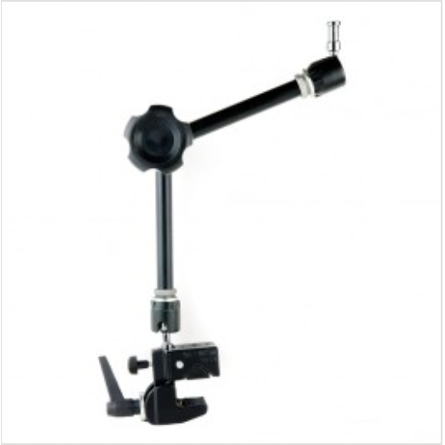 Round Plate for Switch (not pictured)
$40.00 |  | Price for Shipping and Handling Applicable for All Units  PLEASE MAKE SHIPPING LOCATION CLEAR ON REQUEST.
$ |  | Total
Client Name: |  | Contact Phone Number:

Please do not hesitate to contact us with any questions – other options available.

